**Rose Bouquet**

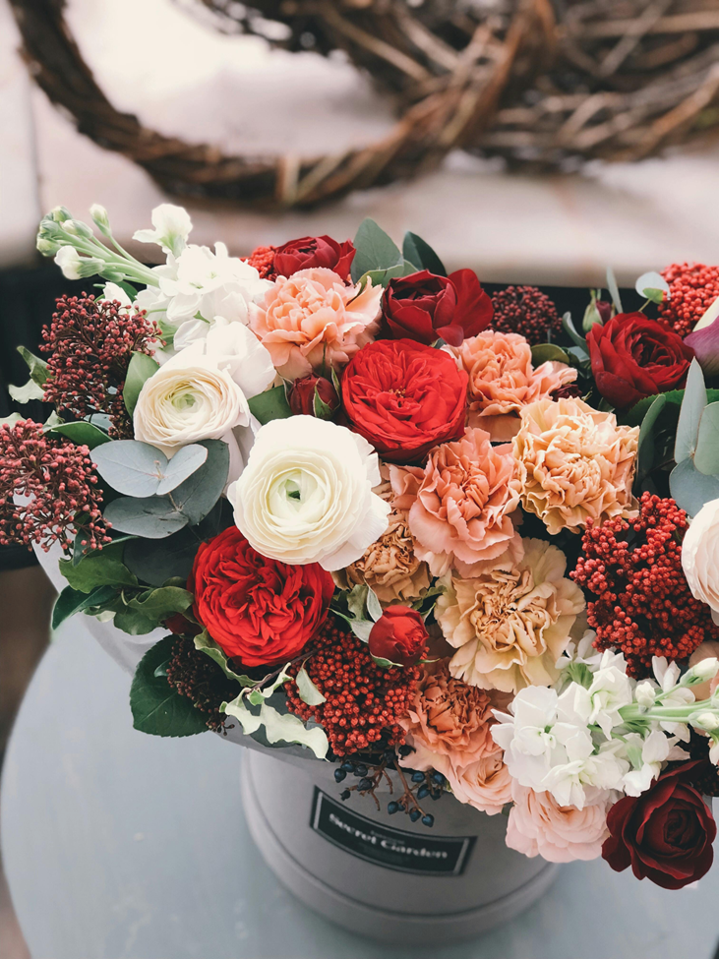

Introducing our exquisite Rose Bouquet, a timeless expression of love and elegance. Handcrafted with care, each bouquet features a curated selection of vibrant, fragrant roses meticulously arranged to captivate the senses. Perfect for any occasion, from romantic gestures to heartfelt celebrations, our Rose Bouquet is a symbol of beauty and affection that will leave a lasting impression.

**CATEGORIES:** Classic Roses, Romantic Roses ,Elegant Roses, Passionate Roses ,Timeless Roses.

**INFORMATION**: A rose bouquet is a collection of rose flowers pieced together and formed to make a decorative shape. A bouquet of roses can be arranged in different shapes and with different styles to fit a purpose.

**Price**: ~~$49.00~~ $40.00